Real Time ADAS Collision Avoidance System with Sensor Fusion, Fault Isolation, Mixed – Critically Scheduling & Safety Supervision
A Mini project Report submitted in completion of the
PEP Embedded training
Submitted by

SHARAVANA PRIYAN S S (312325106170)
BACHELOR OF ENGINEERING
IN
ELECTRONICS AND COMMUNICATION ENGINEERING


St. JOSEPH’S COLLEGE OF ENGINEERING
(An AUTONOMOUS INSTITUTION)


ANNA UNIVERSITY, CHENNAI – 600 025
SEPTEMBER, 2026

CONTENTS
S. NO | TITLE | PAGE NO
1. | AIM | 8
2. | MATERIALS/REQUIREMENT | 8, 9
3. | WORKING PRINCIPLE | 9, 10
4. | CIRCUIT DESCRIPTION | 10, 11
5. | SOURCE CODE (EMBEDDED C) | 12
6. | OUTPUT RESULTS | 13
7. | RESULT | 15
8. | APPLICATION | 15
9. | CONCLUSIONS | 15, 16

DECLARATION

We hereby declare that the project work entitled “Real-Time ADAS Collision Avoidance System with Sensor Fusion, Fault Isolation, Mixed-Criticality Scheduling & Safety Supervision” submitted to St. Joseph’s College of Engineering is a record of original work done by us under the PEP Embedded Systems Domain.

Place: Chennai
Date: 23.09.2026

Student Name: SHARAVANA PRIYAN S S
Register No: 312325106170

ABSTRACT
The Real-Time ADAS Collision Avoidance System with Sensor Fusion, Fault Isolation, Mixed-Criticality Scheduling & Safety Supervision is an ESP32-based four-wheel vehicle prototype developed to demonstrate real-time collision avoidance and safety-aware vehicle control. The main objective of the project is to provide controlled vehicle movement through Bluetooth while continuously monitoring the surrounding environment and vehicle motion.

The system uses an HC-SR04 ultrasonic sensor and IR sensors for obstacle detection and an MPU6050 for monitoring vehicle motion. The ESP32 acts as the main controller and processes the sensor information before controlling the four DC motors through two L298N motor drivers. Bluetooth commands received from a mobile phone are used for forward, backward, left, right and stop operations.

The proposed system incorporates the concepts of sensor fusion, fault isolation, mixed-criticality scheduling and safety supervision. Safety-related operations are given higher priority than normal movement commands. When a dangerous obstacle condition is detected, the safety mechanism can override the normal Bluetooth command and stop the vehicle. An OLED display, red LED and buzzer provide system and safety indications.

The prototype demonstrates the integration of sensing, communication, motor control and safety mechanisms in a real-time embedded system. The project provides a foundation for further development of advanced automotive safety and autonomous vehicle applications.

LIST OF FIGURES
S. NO | TITLE | PAGE NO
1. | ESP32 – BASED CIRCUIT CONNECTION | 10
2. | FOUR – WHEEL VEHICLE PROTOTYPE | 14

LIST OF TABLES
S. NO | TITLE | PAGE NO
1. | Software Tools | 8
2. | Hardware Components | 8,9
3. | Working Principle | 9, 10
4. | Motor Driver 1 Connections | 11
5. | Motor Driver 2 Connections | 11

LIST OF FIGURES
ABBREVIATION | EXPANSION
ADAS | Advanced Driver Assistance System
ESP32 | Espressif 32-bit Microcontroller
IR | Infrared
HC-SR04 | Ultrasonic Distance Sensor Module
MPU6050 | 6-Axis Motion Sensor
OLED | Organic Light-Emitting Diode
L298N | Dual H-Bridge Motor Driver
PWM | Pulse Width Modulation
I2C | Inter-Integrated Circuit
GPIO | General Purpose Input/Output
Bluetooth | Short-Range Wireless Communication Technology
TTC | Time to Collision
RTOS | Real-Time Operating System
CPU | Central Processing Unit
DC | Direct Current
AGV | Automated Guided Vehicle

1. Aim
To design and develop a Real-Time Advanced Driver Assistance System (ADAS) Collision Avoidance System using an ESP32-based four-wheel vehicle prototype. The system uses multiple sensors such as an ultrasonic sensor, IR sensors and MPU6050 to monitor the vehicle surroundings and motion. Sensor data is processed using sensor fusion, while fault isolation is used to identify abnormal sensor conditions. Real-time tasks are managed using mixed-criticality scheduling, and a safety supervisor can override normal Bluetooth-based vehicle control and stop the vehicle when a dangerous collision condition is detected
2. Materials/Requirements
2.1 Software Tools
Tool | Purpose
Arduino IDE | Writing and compiling Embedded C program for ESP32
Bluetooth Controller App | Sending movement commands to the vehicle
Serial Monitor | Monitoring sensor values and system status

2.2 Hardware Components
S.NO | Component | Role in the Project
1 | ESP32 Development Board | Main controller – processes sensor data and controls the vehicle
2 | L298N Motor Driver | Drives and controls the DC motors
3 | DC Gear Motors | Provides movement to the four-wheel vehicle
4 | HC-SR04 Ultrasonic Sensor | Measures distance to obstacles
5 | IR Sensors | Provides additional obstacle detection
6 | MPU6050 | Measures acceleration and angular motion of the vehicle
7 | OLED Display | Displays vehicle status, distance and Bluetooth status
8 | Buzzer | Provides audible warning during obstacle detection
9 | Red LED | Provides visual safety indication
10 | Lithium Battery | Provides power to the vehicle
11 | Switch | Enables or disables the vehicle
12 | Four-Wheel Chassis | Mechanical platform for the vehicle
13 | Connecting Wires | Electrical interconnections
14 | Breadboard | Prototype circuit connections

3. Working Principle
The proposed system is a four-wheel vehicle controlled through a mobile phone using Bluetooth. The ESP32 acts as the main controller and receives movement commands from the mobile application.
The vehicle continuously monitors the surrounding environment using an ultrasonic sensor and IR sensors. The MPU6050 provides information about vehicle motion and orientation.
The basic operation is:
Step | Action | Detail
1 | Bluetooth Command | Mobile phone sends F, B, L, R or S command
2 | Command Processing | ESP32 receives and processes the command
3 | Sensor Monitoring | Ultrasonic, IR and MPU6050 monitor vehicle conditions
4 | Sensor Fusion | Sensor information is combined for improved decision making
5 | Fault Isolation | Abnormal or unavailable sensor information is identified
6 | Collision Risk | The system checks whether the vehicle is approaching an obstacle
7 | Safety Supervision | Safety logic verifies whether the requested movement is safe
8 | Motor Control | L298N drivers control the four motors
9 | Emergency Action | During a dangerous condition, the vehicle is stopped

The Bluetooth movement commands are:
F → Forward
B → Backward
L → Left
R → Right
S → Stop
The important feature of the system is that safety control has priority over normal Bluetooth movement control. If a dangerous obstacle condition is detected, the safety mechanism can override the forward command and stop the vehicle.
4. Circuit Description
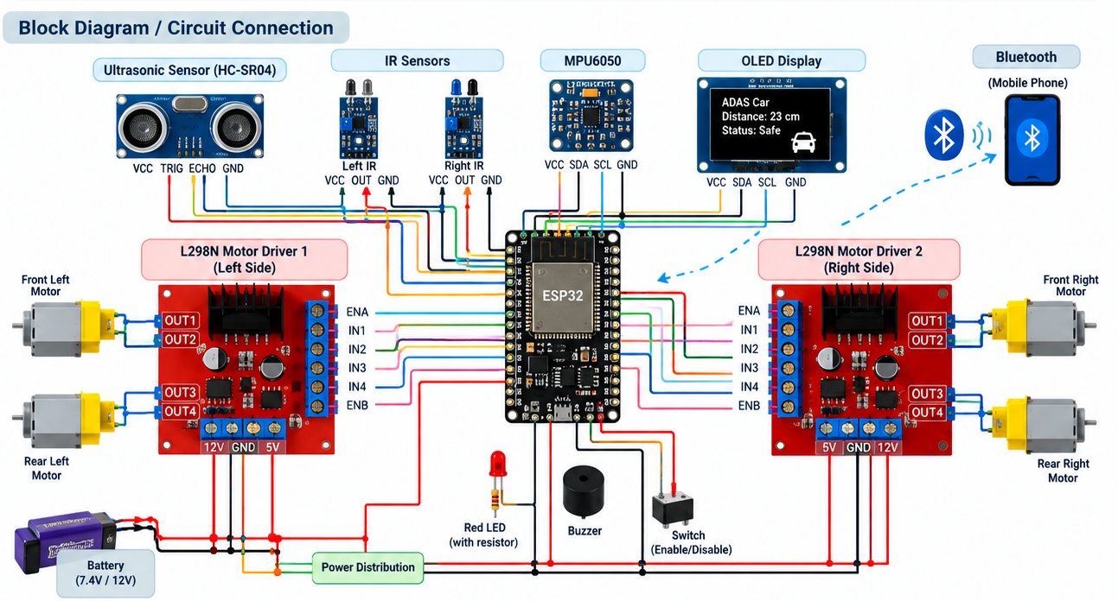

The circuit is designed around the ESP32 development board. The ESP32 receives Bluetooth commands, processes sensor information and controls the motor drivers.
Two L298N motor drivers are used to control the four DC motors. The motors are arranged as left and right motor groups to provide forward, backward and turning movements.Motor Driver Connections
L298N Motor Driver 1
Signal | ESP32 Pin | Purpose
ENA | GPIO 33 | Speed control
IN1 | GPIO 26 | Motor direction
IN2 | GPIO 27 | Motor direction
ENB | GPIO 32 | Speed control
IN3 | GPIO 14 | Motor direction
IN4 | GPIO 25 | Motor direction
L298N Motor Driver 2
Signal | ESP32 Pin | Purpose
ENA | GPIO 23 | Speed control
IN1 | GPIO 4 | Motor direction
IN2 | GPIO 16 | Motor direction
ENB | GPIO 13 | Speed control
IN3 | GPIO 17 | Motor direction
IN4 | GPIO 19 | Motor direction
Sensor Connections
Component | ESP32 Pin | Purpose
HC-SR04 TRIG | GPIO 5 | Trigger signal
HC-SR04 ECHO | GPIO 18 | Echo signal
Left IR | GPIO 34 | Left obstacle detection
Right IR | GPIO 35 | Right obstacle detection
MPU6050 SDA | GPIO 21 | I2C data
MPU6050 SCL | GPIO 22 | I2C clock
The OLED display uses the I2C communication interface. The buzzer and red LED are used for safety indication.
The motor drivers are powered from the battery supply, while the ESP32 provides the control signals. A common ground is maintained between the ESP32, motor drivers and sensors.
5. Source Code (Embedded C)
The program is developed using Embedded C/C++ in the Arduino IDE. The software initializes the ESP32 peripherals, Bluetooth communication, sensors and motor drivers.
The main functions of the program include:
1. Bluetooth initialization
2. Motor control
3. Ultrasonic distance measurement
4. IR sensor monitoring
5. MPU6050 monitoring
6. Sensor fusion
7. Fault detection
8. Collision-risk evaluation
9. Safety supervision
10. OLED status display
The Bluetooth commands are processed as follows:
F → Move Forward
B → Move Backward
L → Turn Left
R → Turn Right
S → Stop
The ultrasonic sensor measures the distance between the vehicle and the obstacle. When the measured distance becomes less than the predefined safety limit, forward movement is blocked and the warning system is activated.
The safety supervisor has higher priority than normal movement control. Therefore, a Bluetooth forward command cannot continuously operate the vehicle when a dangerous obstacle condition is detected.

6. Simulation & Output Results
The system operation can be verified through simulation and physical prototype testing. The Bluetooth commands, motor operation, obstacle detection and safety response are observed during testing.
Test Case 1 – Forward Movement
When the Bluetooth command F is received and no obstacle is detected, the vehicle moves forward.
Bluetooth Command: F
Obstacle: NOT DETECTED
Vehicle Status: FORWARD
Motor: RUNNING
Test Case 2 – Obstacle Detection
When an obstacle is detected within the defined safety distance, the forward movement is stopped.
Obstacle: DETECTED
Warning: ON
Motor: STOPPED
Test Case 3 – Backward Movement
When B is received, the motor direction is reversed and the vehicle moves backward.
Bluetooth Command: B
Vehicle Status: BACKWARD
Motor: RUNNING
Test Case 4 – Turning
The commands L and R control the left and right motor groups to turn the vehicle.
L → LEFT TURN
R → RIGHT TURN
Test Case 5 – Stop
When S is received, all motor outputs are disabled.
Bluetooth Command: S
Vehicle Status: STOP
Motor: STOPPED
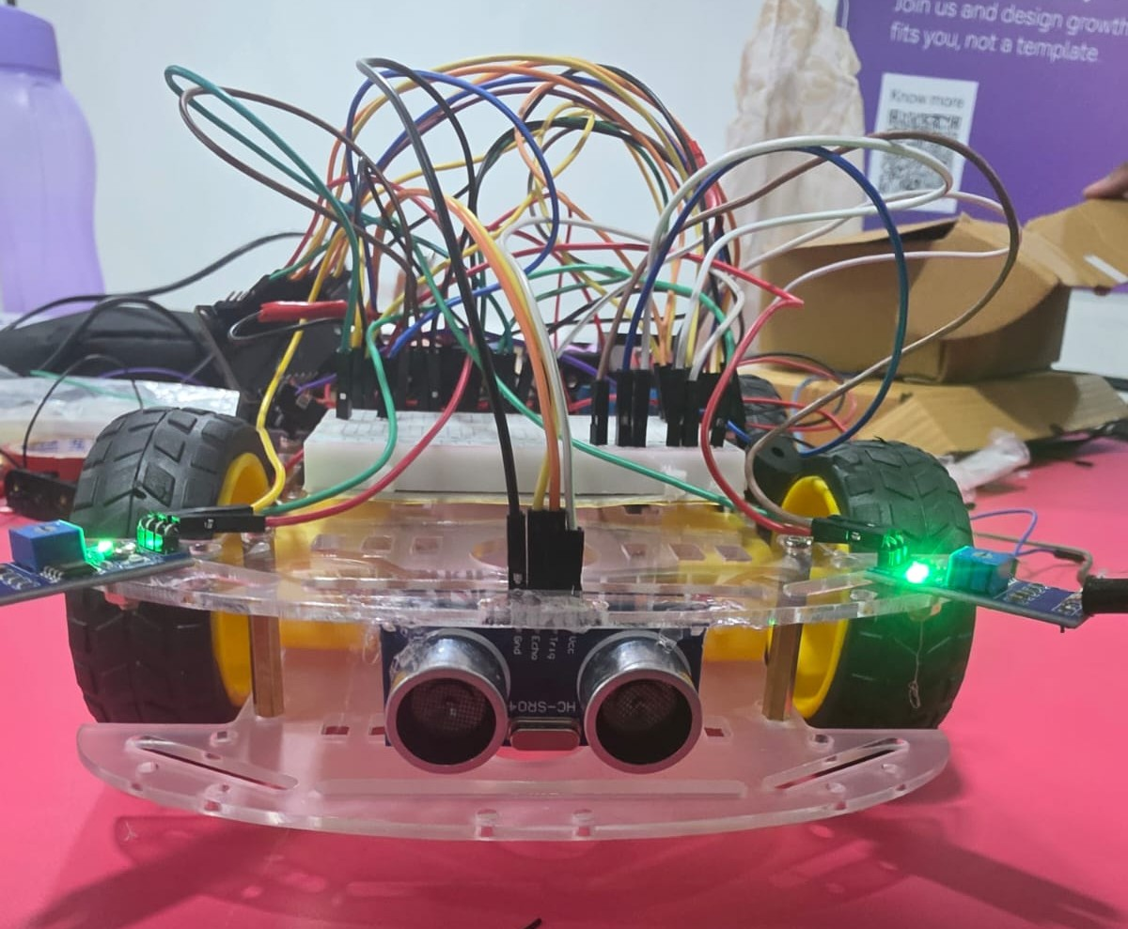

6.1 Observation
- During testing, the ESP32 successfully received movement commands through Bluetooth.
- The L298N motor drivers controlled the four DC motors according to the received commands.
- The ultrasonic sensor successfully measured the distance to an obstacle.
- When an obstacle entered the defined safety region, forward movement was stopped.
- The buzzer and red LED provided safety indications during obstacle detection.
- The OLED displayed the vehicle status and measured distance.
- The physical switch provided an additional method to enable or disable the vehicle.
- The safety-control concept demonstrated that normal vehicle commands can be overridden during a dangerous condition.

7. Result
The Real-Time ADAS Collision Avoidance System was successfully designed as an ESP32-based four-wheel vehicle prototype. The system provides Bluetooth-based vehicle control and continuously monitors the surrounding environment using multiple sensors.
The ultrasonic and IR sensors provide obstacle-related information, while the MPU6050 provides vehicle motion information. The proposed architecture incorporates sensor fusion, fault isolation, real-time task prioritization and safety supervision to improve the reliability of the vehicle control system.
The prototype successfully demonstrates the basic operation of a real-time safety-aware collision avoidance system.
8. Applications (Real-Time)
- Automotive ADAS — Collision detection and driver assistance.
- Autonomous Vehicles — Obstacle detection and collision avoidance.
- Industrial AGVs — Safe movement of automated guided vehicles.
- Warehouse Robots — Obstacle detection in automated transportation.
- Mobile Robotic Systems — Real-time navigation and safety monitoring.
- Smart Transportation Systems — Vehicle monitoring and safety assistance.
- Safety-Critical Embedded Systems — Demonstration of fault monitoring and safety supervision.
- Educational Platforms — Demonstration of sensor fusion and real-time embedded control.
9. Conclusion
This mini project successfully demonstrated a Real-Time ADAS Collision Avoidance System using an ESP32-based four-wheel vehicle. The system integrates Bluetooth vehicle control, multiple sensors, motor drivers and safety monitoring into a single embedded platform.
The ultrasonic and IR sensors provide obstacle detection, while the MPU6050 provides vehicle motion information. The sensor fusion approach allows information from multiple sensors to be considered together, while fault isolation provides a mechanism for identifying abnormal sensor conditions.
The mixed-criticality scheduling concept gives higher priority to safety-related operations, and the safety supervisor can override normal Bluetooth commands when a dangerous collision condition is detected.
The project demonstrates important embedded-system concepts including Bluetooth communication, sensor interfacing, motor control, I2C communication, sensor fusion, fault monitoring, real-time scheduling and safety supervision. It provides a foundation for further development toward advanced automotive safety systems.

